**BHAGIRATH PUBLIC**



**SCHOOL**

**At**



**A Glance**



**Session**

**2025**



**Syllabus**

**2024~~-~~**

**Subject Mathematics**



**Class 3**

**Subject**

**Priya**

**Month Name of the Chapters Activities Exam Cycle**

**Undertaken**



**Teacher :Kannu**



**Srivastava**

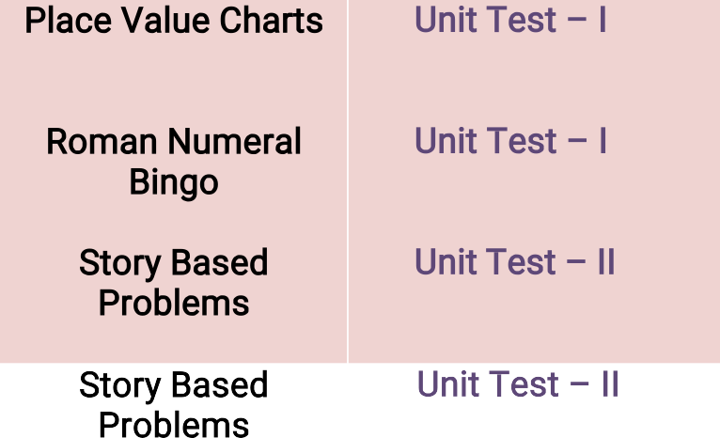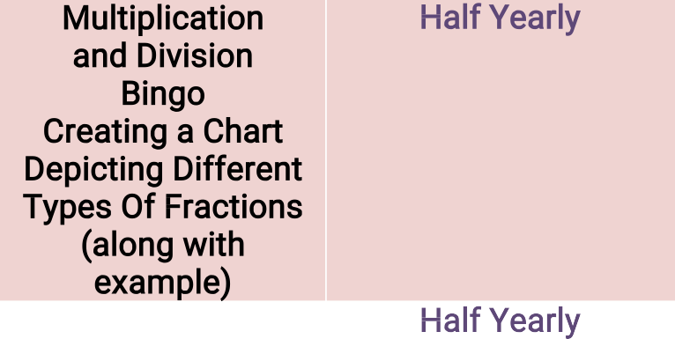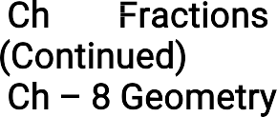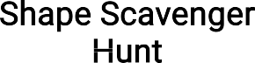

April

May

August

July

1. Ch ~~–~~1 ~~–~~

4 ~~–~~ Digit Numbers

1. **Ch ~~–~~ 2 Roman Numbers**
2. **Ch -3 Addition Of 4 ~~–~~ Digit Numbers**
3. **Ch – 4 Subtraction Of 4 ~~–~~ Digit Numbers**
4. **Ch ~~–~~ 5 Multiplication**
5. **Ch ~~–~~ 6 Division**
6. **Ch ~~–~~ 7 Fractions**

Ch ~~–~~ 7 Fractions (Continued)

1. **Ch – 8 Geometry**

Place Value Charts

Roman Numeral Bingo

Story Based Problems

Story Based Problems Multiplication and Division Bingo

Creating a Chart Depicting Different Types Of Fractions (along with example)

Shape Scavenger Hunt

Unit Test – I Unit Test – I Unit Test – II

Unit Test – II Half Yearly

Half Yearly

1.  **Ch ~~–~~ 9 Patterns Puzzle Revision For Half ~~–~~ YearlyExamination**

**January**

**December**

**November**

**October**

**September**

1. **Ch ~~–~~ 10 Money**

**Ch**

Market Place Recreation

Unit Test – III Unit Test - IV

~~–~~ 11

Time Matching Game

1. **Ch ~~–~~ 12 Length**

**Time**

1. **Ch ~~–~~ 13 Weight**

14. Ch ~~–~~ 14 Capacity

Outdoor Nature Walk

Weight Sorting Measuring Cup Exploration

Annual Examination Annual Examination

Annual Examination

February

**Handling**

**Ch ~~–~~ 15 Data**

**15.**

Revision For Annual Examination

Worksheet Annual Examination

Annual Examination

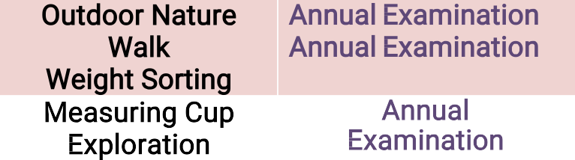

15

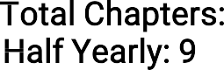

**Overview: Total Chapters: Half Yearly: 9**



**Annual**



**Examination: 6**